A1128-ME-Moabite Script-Limestone Cobble-800 BCE



Fig. 1. Paleo Hebrew Script-Limestone Cobble-ca 800 BCE

**Display Description:** Paleo-Hebrew stone document composed between 900 and 600 BCE on a limestone cobble, which was sent as a letter to a friend or business partner.

|  |  |  |  |  |  |  |
| --- | --- | --- | --- | --- | --- | --- |
| K[Khof](https://en.wikipedia.org/wiki/File:Early_Aramaic_character_-_khof.png) | S[Shin](https://en.wikipedia.org/wiki/File:Early_Aramaic_character_-_shin.png) | N[Nun](https://en.wikipedia.org/wiki/File:Early_Aramaic_character_-_nun.png) | M[Mem](https://en.wikipedia.org/wiki/File:Early_Aramaic_character_-_mem.png) | E[Heh](https://en.wikipedia.org/wiki/File:Early_Aramaic_character_-_heh.png) | B[Bet](https://en.wikipedia.org/wiki/File:Early_Aramaic_character_-_Beth.png) | R[Resh](https://en.wikipedia.org/wiki/File:Early_Aramaic_character_-_resh.png) |
| E[Heh](https://en.wikipedia.org/wiki/File:Early_Aramaic_character_-_heh.png) | N[Nun](https://en.wikipedia.org/wiki/File:Early_Aramaic_character_-_nun.png) | S[Shin](https://en.wikipedia.org/wiki/File:Early_Aramaic_character_-_shin.png) | R[Resh](https://en.wikipedia.org/wiki/File:Early_Aramaic_character_-_resh.png) | R[Resh](https://en.wikipedia.org/wiki/File:Early_Aramaic_character_-_resh.png) |  |  |
| M[Mem](https://en.wikipedia.org/wiki/File:Early_Aramaic_character_-_mem.png) | R[Resh](https://en.wikipedia.org/wiki/File:Early_Aramaic_character_-_resh.png) | K[Khof](https://en.wikipedia.org/wiki/File:Early_Aramaic_character_-_khof.png) | S[Shin](https://en.wikipedia.org/wiki/File:Early_Aramaic_character_-_shin.png) | N[Nun](https://en.wikipedia.org/wiki/File:Early_Aramaic_character_-_nun.png) |  |  |
| R[Resh](https://en.wikipedia.org/wiki/File:Early_Aramaic_character_-_resh.png) | S[Shin](https://en.wikipedia.org/wiki/File:Early_Aramaic_character_-_shin.png) | N[Nun](https://en.wikipedia.org/wiki/File:Early_Aramaic_character_-_nun.png) | N[Nun](https://en.wikipedia.org/wiki/File:Early_Aramaic_character_-_nun.png) |  |  |  |
|  | R[Resh](https://en.wikipedia.org/wiki/File:Early_Aramaic_character_-_resh.png) | N[Nun](https://en.wikipedia.org/wiki/File:Early_Aramaic_character_-_nun.png) |  |  |  |  |

Fig. 2 Transcription of Paleo Hebrew Script-Limestone Cobble-ca 800 BCE

**Case no.: 2**

**Accession Number: A1128**

**Formal Label: Paleo Hebrew stone letter**

**LC Classification:** PJ3091 .E94

**Date or Time Horizon:** ca. 800 BCE

**Geographical Area:** Jerusalem

**Map, Google Earth Pro**

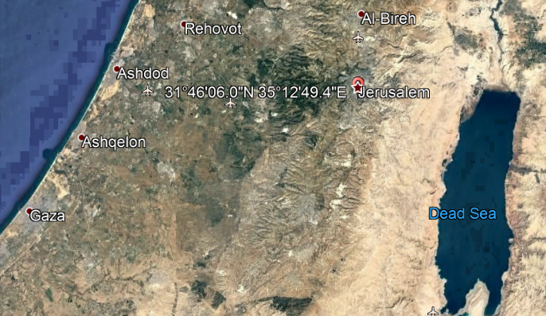

**GPS coordinates:** 31.76832 35.21371; 31º46'5.95" N 35º12'49.36" E

**Cultural Affiliation:** Hebrew

**Media: limestone, charcoal.**

**Dimensions:** H 5 in, W. 3.5 in.

**Weight: 453.592 g, 1 lb**

**Condition: original.**

**Provenance:** Jerusalem area.

**Discussion:**

The Paleo-Hebrew script ( הכתב העברי הקדום‎), a variant of the Phoenician alphabet, contains 22 consonants and dates from 900 to 400 BCE, when the Aramaic alphabet was adopted. Samaritans, now fewer than 1000 people, have continued to use a derivative of the Paleo-Hebrew alphabet, known as the Samaritan alphabet.

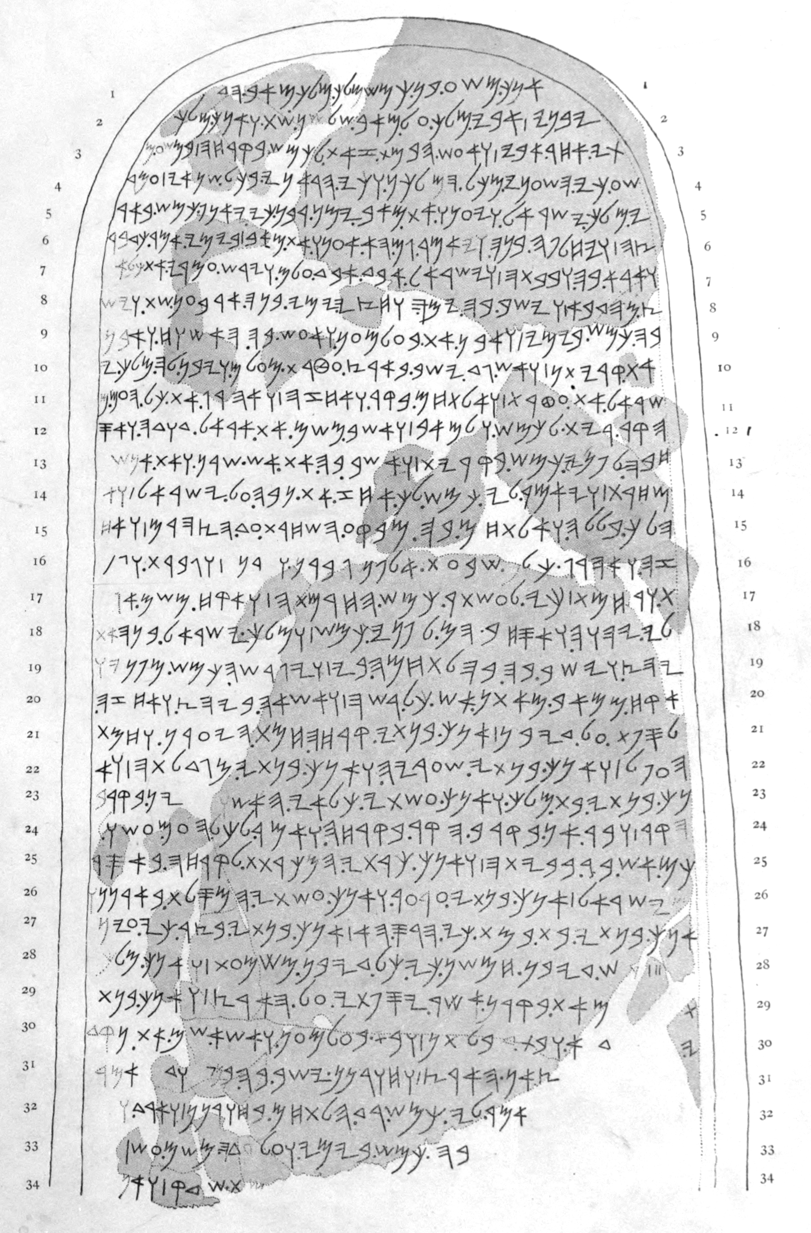

Drawing of the Mesha Stele (or Moabite Stone) by Mark Lidzbarski, published 1898.

set up around 840 BCE by King [Mesha](https://en.wikipedia.org/wiki/Mesha) of [Moab](https://en.wikipedia.org/wiki/Moab) (a kingdom located in modern [Jordan](https://en.wikipedia.org/wiki/Jordan)). Mesha tells how [Chemosh](https://en.wikipedia.org/wiki/Chemosh" \o "Chemosh), the god of Moab, had been angry with his people and had allowed them to be subjugated to Israel, but at length Chemosh returned and assisted Mesha to throw off the yoke of Israel and restore the lands of Moab. Mesha describes his many building projects.[[1]](https://en.wikipedia.org/wiki/Mesha_Stele#cite_note-FOOTNOTERollston201053.E2.80.9354-1) It is written in the [Phoenician alphabet](https://en.wikipedia.org/wiki/Phoenician_alphabet).

The stone was discovered intact by [Frederick Augustus Klein](https://en.wikipedia.org/wiki/Frederick_Augustus_Klein), an [Anglican](https://en.wikipedia.org/wiki/Anglican) missionary, at the site of ancient [Dibon](https://en.wikipedia.org/wiki/Dibon" \o "Dibon) (now [Dhiban, Jordan](https://en.wikipedia.org/wiki/Dhiban,_Jordan" \o "Dhiban, Jordan)), in August 1868. Klein was led to it by a local [Bedouin](https://en.wikipedia.org/wiki/Bedouin), although neither of them could read the text.[[2]](https://en.wikipedia.org/wiki/Mesha_Stele#cite_note-Lemaire1994-2) Before it could be seen by another European, the next year it was smashed by [local villagers](https://en.wikipedia.org/wiki/Bani_Hamida) during a dispute over its ownership. A ["squeeze"](https://en.wikipedia.org/wiki/Squeeze_(copying_method)) (a [papier-mâché](https://en.wikipedia.org/wiki/Papier-m%C3%A2ch%C3%A9) impression) had been obtained by a local Arab on behalf of [Charles Simon Clermont-Ganneau](https://en.wikipedia.org/wiki/Charles_Simon_Clermont-Ganneau), and fragments containing most of the inscription (613 letters out of about a thousand) were later recovered and pieced together. The squeeze and the reassembled stele are now in the [Louvre Museum](https://en.wikipedia.org/wiki/Louvre_Museum).[[2]](https://en.wikipedia.org/wiki/Mesha_Stele#cite_note-Lemaire1994-2)

The Mesha stele is the longest [Iron Age](https://en.wikipedia.org/wiki/Iron_Age) inscription ever found in the region, constitutes the major evidence for the [Moabite language](https://en.wikipedia.org/wiki/Moabite_language), and is a "corner-stone of Semitic epigraphy and Palestinian history".[[3]](https://en.wikipedia.org/wiki/Mesha_Stele#cite_note-FOOTNOTEAlbright1945250-3) The stele, whose story parallels, with some differences, an episode in the Bible's [Books of Kings](https://en.wikipedia.org/wiki/Books_of_Kings) (2 Kings 3:4–8), provides invaluable information on the Moabite language and the political relationship between Moab and Israel at one moment in the 9th century BCE.[[4]](https://en.wikipedia.org/wiki/Mesha_Stele#cite_note-FOOTNOTERollston201054-4) It is the most extensive inscription ever recovered that refers to the [kingdom of Israel](https://en.wikipedia.org/wiki/Kingdom_of_Israel_(Samaria)) (the "House of Omri"); it bears the earliest certain extra-biblical reference to the Israelite god [Yahweh](https://en.wikipedia.org/wiki/Yahweh), and—if French scholar [André Lemaire](https://en.wikipedia.org/wiki/Andr%C3%A9_Lemaire)'s reconstruction of a portion of line 31 is correct—the earliest mention of the "House of [David](https://en.wikipedia.org/wiki/David)" (i.e., the [kingdom of Judah](https://en.wikipedia.org/wiki/Kingdom_of_Judah)).[[2]](https://en.wikipedia.org/wiki/Mesha_Stele#cite_note-Lemaire1994-2) It is also one of four known contemporary inscriptions containing the name of Israel, the others being the [Merneptah Stele](https://en.wikipedia.org/wiki/Merneptah_Stele" \o "Merneptah Stele), the [Tel Dan Stele](https://en.wikipedia.org/wiki/Tel_Dan_Stele), and the [Kurkh Monolith](https://en.wikipedia.org/wiki/Kurkh_Monolith" \o "Kurkh Monolith).[[5]](https://en.wikipedia.org/wiki/Mesha_Stele#cite_note-FOOTNOTELemche199846.2C_62-5)[[6]](https://en.wikipedia.org/wiki/Mesha_Stele#cite_note-6)[[7]](https://en.wikipedia.org/wiki/Mesha_Stele#cite_note-7)

The Moabite language is an extinct [Canaanite language](https://en.wikipedia.org/wiki/Canaanite_language), spoken in Moab (modern day central-western [Jordan](https://en.wikipedia.org/wiki/Jordan)) in the early first millennium BC. It was written using a variant of the [Phoenician alphabet](https://en.wikipedia.org/wiki/Phoenician_alphabet).[[33]](https://en.wikipedia.org/wiki/Moab#cite_note-ISBE-33)

Most of our knowledge about Moabite comes from the [Mesha Stele](https://en.wikipedia.org/wiki/Mesha_Stele),[[33]](https://en.wikipedia.org/wiki/Moab" \l "cite_note-ISBE-33) which is the only known extensive text in this language. In addition there are the three line [El-Kerak Inscription](https://en.wikipedia.org/wiki/El-Kerak_Inscription) and a few seals. The main features distinguishing Moabite from fellow Canaanite languages such as Hebrew are: a plural in *-în* rather than *-îm* (e.g. *mlkn* "kings" for [Biblical Hebrew](https://en.wikipedia.org/wiki/Biblical_Hebrew) *məlākîm*), like [Aramaic](https://en.wikipedia.org/wiki/Aramaic_language) and [Arabic](https://en.wikipedia.org/wiki/Arabic_language); retention of the feminine ending *-at* or "-ah" which Biblical Hebrew reduces to *-āh* only (e.g. *qiryat* or "qiryah" "town", Biblical Hebrew *qiryāh*) but retains in the construct state nominal form (e.g.*qiryát yisrael* "town of Israel"); and retention of a verb form with infixed *-t-*, also found in [Arabic](https://en.wikipedia.org/wiki/Arabic_language) and [Akkadian](https://en.wikipedia.org/wiki/Akkadian_language) (*w-’ltḥm* "I began to fight", from the root *lḥm*.)

According to [*Glottolog*](https://en.wikipedia.org/wiki/Glottolog), referencing Huehnergard & Rubin (2011), Moabite was not a distinct language from Hebrew.[[32]](https://en.wikipedia.org/wiki/Moab#cite_note-Glottolog2-32)

**References:**

Watson, Wilfred G E. 1999. *Handbook of Ugaritic Studies* (Leiden: Brill), p. 90.

|  |  |  |  |  |  |  |  |  |
| --- | --- | --- | --- | --- | --- | --- | --- | --- |
| **Hieroglyph** | **Proto-Sinaitic** | [**IPA**](https://en.wikipedia.org/wiki/IPA)**value** | **reconstructed name** | [**Phoenician**](https://en.wikipedia.org/wiki/Phoenician_alphabet) | [**Paleo-Hebrew**](https://en.wikipedia.org/wiki/Paleo-Hebrew_alphabet) | [**Aramaic**](https://en.wikipedia.org/wiki/Aramaic_alphabet) | [**Hebrew**](https://en.wikipedia.org/wiki/Biblical_Hebrew) | [Archaic Greek](https://en.wikipedia.org/wiki/Archaic_Greek_alphabets), [Modern Greek](https://en.wikipedia.org/wiki/Greek_alphabet), [Etruscan](https://en.wikipedia.org/wiki/Old_Italic_script#Etruscan_alphabet), and [Latin](https://en.wikipedia.org/wiki/Latin_alphabet) |
| |  |  | | --- | --- | | |  | | --- | | F1 | | | [Aleph](https://en.wikipedia.org/wiki/File:Proto-Canaanite_-_aleph.png) | /ʔ/ | [ʾalp](https://en.wikipedia.org/wiki/%CA%BEalp) "ox" | [Aleph](https://en.wikipedia.org/wiki/File:Phoenician_aleph.svg) | [Aleph](https://en.wikipedia.org/wiki/File:Early_Aramaic_character_-_Alaph.png) | [Aleph.svg](https://en.wikipedia.org/wiki/File:Aleph.svg) | א | [Greek Alpha 03.svg](https://en.wikipedia.org/wiki/File:Greek_Alpha_03.svg) [Α](https://en.wikipedia.org/wiki/Alpha_(letter)) [𐌀 A](https://en.wikipedia.org/wiki/A) |
| |  |  | | --- | --- | | |  | | --- | | O1 | | | [Bet](https://en.wikipedia.org/wiki/File:Proto-Canaanite_-_bet.png) | /b/ | [bet](https://en.wikipedia.org/wiki/Bet_(letter)) "house" | [Beth](https://en.wikipedia.org/wiki/File:Phoenician_beth.svg) | [Bet](https://en.wikipedia.org/wiki/File:Early_Aramaic_character_-_Beth.png) | [Beth.svg](https://en.wikipedia.org/wiki/File:Beth.svg) | ב | [Greek Beta 16.svg](https://en.wikipedia.org/wiki/File:Greek_Beta_16.svg) [Β](https://en.wikipedia.org/wiki/Beta_(letter)) [𐌁 B](https://en.wikipedia.org/wiki/B) |
| |  |  | | --- | --- | | |  | | --- | | A28 | | | [Heh](https://en.wikipedia.org/wiki/File:Proto-Canaanite_-_heh.png) | /h/ | *hll* "jubilation" > *he* "window" | [He](https://en.wikipedia.org/wiki/File:Phoenician_he.svg) | [Heh](https://en.wikipedia.org/wiki/File:Early_Aramaic_character_-_heh.png) | [He0.svg](https://en.wikipedia.org/wiki/File:He0.svg) | ה | [Greek Epsilon archaic.svg](https://en.wikipedia.org/wiki/File:Greek_Epsilon_archaic.svg) [Ε](https://en.wikipedia.org/wiki/%CE%95) [𐌄 E](https://en.wikipedia.org/wiki/E) |
| |  |  | | --- | --- | | |  | | --- | | D46 | | | [Khof](https://en.wikipedia.org/wiki/File:Proto-Canaanite_-_khof.png) | /k/ | [kaf](https://en.wikipedia.org/wiki/Kaph) "palm of hand" | [Kaph](https://en.wikipedia.org/wiki/File:Phoenician_kaph.svg) | [Khof](https://en.wikipedia.org/wiki/File:Early_Aramaic_character_-_khof.png) | [Kaph.svg](https://en.wikipedia.org/wiki/File:Kaph.svg) | כ, ך | [Greek Kappa normal.svg](https://en.wikipedia.org/wiki/File:Greek_Kappa_normal.svg) [Κ](https://en.wikipedia.org/wiki/Kappa) [𐌊 K](https://en.wikipedia.org/wiki/K) |
| |  |  | | --- | --- | | |  | | --- | | N35 | | | [Mem](https://en.wikipedia.org/wiki/File:Proto-Canaanite_-_mem.png) | /m/ | [mayim](https://en.wikipedia.org/wiki/Mayim) "water" | [Mem](https://en.wikipedia.org/wiki/File:Phoenician_mem.svg) | [Mem](https://en.wikipedia.org/wiki/File:Early_Aramaic_character_-_mem.png) | [Mem.svg](https://en.wikipedia.org/wiki/File:Mem.svg) | מ, ם | [Greek Mu 04.svg](https://en.wikipedia.org/wiki/File:Greek_Mu_04.svg) [Μ](https://en.wikipedia.org/wiki/Mu_(letter)) [𐌌 M](https://en.wikipedia.org/wiki/M) |
| |  |  | | --- | --- | | |  | | --- | | I10 | | | [Nun](https://en.wikipedia.org/wiki/File:Proto-Canaanite_-_nun.png) | /n/ | *naḥš* "snake" > [*nun*](https://en.wikipedia.org/wiki/Nun_(letter)) "fish" | [Nun](https://en.wikipedia.org/wiki/File:Phoenician_nun.svg) | [Nun](https://en.wikipedia.org/wiki/File:Early_Aramaic_character_-_nun.png) | [Nun.svg](https://en.wikipedia.org/wiki/File:Nun.svg) | נ, ן | [Greek Nu 01.svg](https://en.wikipedia.org/wiki/File:Greek_Nu_01.svg) [Ν](https://en.wikipedia.org/wiki/%CE%9D) [𐌍 N](https://en.wikipedia.org/wiki/N) |
| |  |  | | --- | --- | | |  | | --- | | D4 | | | [Ayin](https://en.wikipedia.org/wiki/File:Proto-Canaanite_-_ayin.png) | /ʕ/ | [ʿen](https://en.wikipedia.org/wiki/%CA%BFen) "eye" | [Ayin](https://en.wikipedia.org/wiki/File:Phoenician_ayin.svg) | [Ayin](https://en.wikipedia.org/wiki/File:Early_Aramaic_character_-_ayin.png) | [Ayin.svg](https://en.wikipedia.org/wiki/File:Ayin.svg) | ע | [Greek Omicron 04.svg](https://en.wikipedia.org/wiki/File:Greek_Omicron_04.svg) [Ο](https://en.wikipedia.org/wiki/Omicron) [𐌏 O](https://en.wikipedia.org/wiki/O) |
| |  |  | | --- | --- | | |  | | --- | | D1 | | | |  | | --- | | D19 | | | | [Resh](https://en.wikipedia.org/wiki/File:Proto-Canaanite_-_resh.png) | /r/ | [roʾš](https://en.wikipedia.org/wiki/Resh) "head" | [Res](https://en.wikipedia.org/wiki/File:Phoenician_res.svg) | [Resh](https://en.wikipedia.org/wiki/File:Early_Aramaic_character_-_resh.png) | [Resh.svg](https://en.wikipedia.org/wiki/File:Resh.svg) | ר | [Greek Rho pointed.svg](https://en.wikipedia.org/wiki/File:Greek_Rho_pointed.svg) [Greek Rho 03.svg](https://en.wikipedia.org/wiki/File:Greek_Rho_03.svg) [Ρ](https://en.wikipedia.org/wiki/Rho_(letter)) [𐌓 R](https://en.wikipedia.org/wiki/R) |
| |  |  | | --- | --- | | |  | | --- | | Aa32 | | | [Shin](https://en.wikipedia.org/wiki/File:Proto-Canaanite_-_shin.png) | /ʃ/ | *šimš* "[sun](https://en.wikipedia.org/wiki/Apep)" > *šin* "tooth" | [Sin](https://en.wikipedia.org/wiki/File:Phoenician_sin.svg) | [Shin](https://en.wikipedia.org/wiki/File:Early_Aramaic_character_-_shin.png) | [Shin.svg](https://en.wikipedia.org/wiki/File:Shin.svg) | ש | [Greek Sigma normal.svg](https://en.wikipedia.org/wiki/File:Greek_Sigma_normal.svg) [Greek Sigma 18.svg](https://en.wikipedia.org/wiki/File:Greek_Sigma_18.svg) [Σ](https://en.wikipedia.org/wiki/Sigma) [𐌔 S](https://en.wikipedia.org/wiki/S) |
| |  |  | | --- | --- | | |  | | --- | | Z9 | | | [Tof](https://en.wikipedia.org/wiki/File:Proto-Canaanite_-_tof.png) | /t/ | *tāw* "mark" | [Taw](https://en.wikipedia.org/wiki/File:Phoenician_taw.svg) | [Tof](https://en.wikipedia.org/wiki/File:Early_Aramaic_character_-_tof.png) | [Taw.svg](https://en.wikipedia.org/wiki/File:Taw.svg) | ת | [Greek Tau 02.svg](https://en.wikipedia.org/wiki/File:Greek_Tau_02.svg) [Τ](https://en.wikipedia.org/wiki/%CE%A4) [𐌕 T](https://en.wikipedia.org/wiki/T) |

Chart Based on Simons (2011), Figure Two: "Representative selection of proto-Sinaitic characters with comparison to Egyptian hieroglyphs", (p. 38) Figure Three: "Chart of all early proto-Canaanite letters with comparison to proto-Sinaitic signs" (p. 39), Figure Four: "Representative selection of later proto-Canaanite letters with comparison to early proto-Canaanite and proto-Sinaitic signs" (p. 40). See also: Goldwasser (2010), following Albright (1966), "Schematic Table of Proto-Sinaitic Characters" ([fig. 1](http://www.apocalypse2008-2015.com/images/Proto-Sinaitic_Table.gif)). A comparison of glyphs from western ("Proto-Canaanite", Byblos) and southern scripts along with the reconstructed "Linear Ugaritic" (Lundin 1987) is found in Manfried Dietrich and Oswald Loretz, *Die Keilalphabete: die phönizisch-kanaanäischen und altarabischen Alphabete in Ugarit*, Ugarit-Verlag, 1988, p. 102, reprinted in Wilfred G. E. Watson, Nicolas Wyatt (eds.), *Handbook of Ugaritic Studies* (1999), [p. 86](https://books.google.ch/books?id=0Z2Jo01iq1YC&pg=PA86#v=onepage&q&f=false).

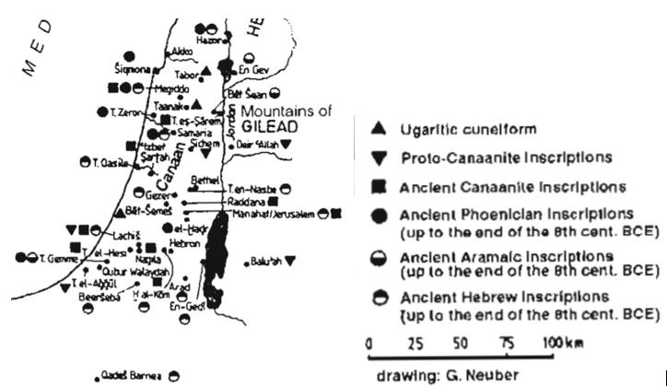

Levant Scripts ca 1000-900 BCE. After Watson 1999: 90.

|  |  |
| --- | --- |
|  |  |

Watson, Wilfred G. E. and Nicolas Wyatt (eds.). 1999. *Handbook of Ugaritic Studies*